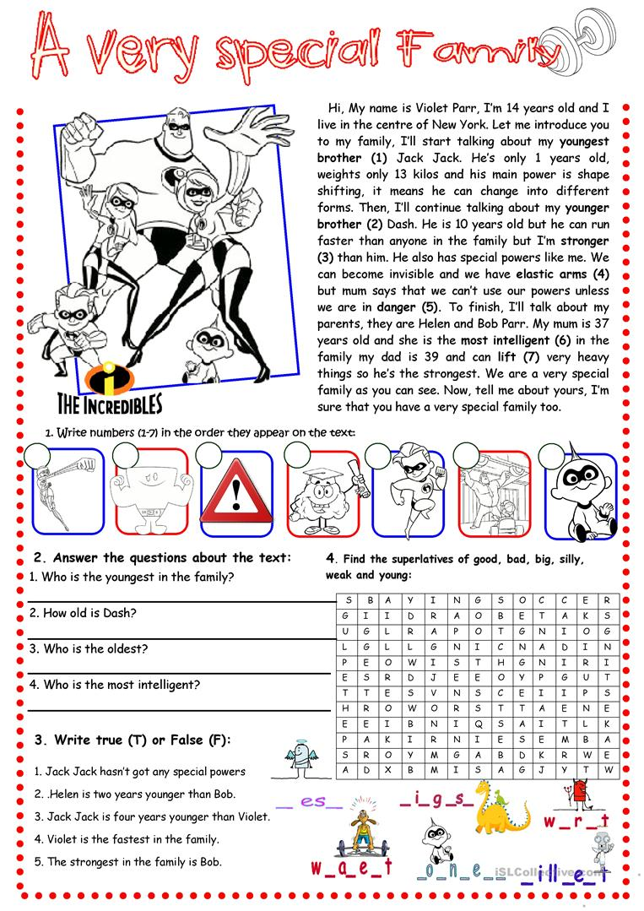

**Superlative adjectives**

1. Complete with a superlative adjective and all the necessary words.

1. London is ...................................... (large) city in England.

2. Cheetahs are ................................ (fast) animals in the world.

3. Whales are ..................................... (big) animals.

4. San Francisco is ......................................... (beautiful) city in the United States.

5. Summer is .......................................(good) season of the year.

2. Write the superlative form.

1. good .......... 6. pretty ..........

2. far .......... 7. small ..........

3. expensive .......... 8. nice ..........

4. old .......... 9. comfortable..........

5. young .......... 10. bad ..........

3. Look at the table and write true sentences with the adjectives in the box.

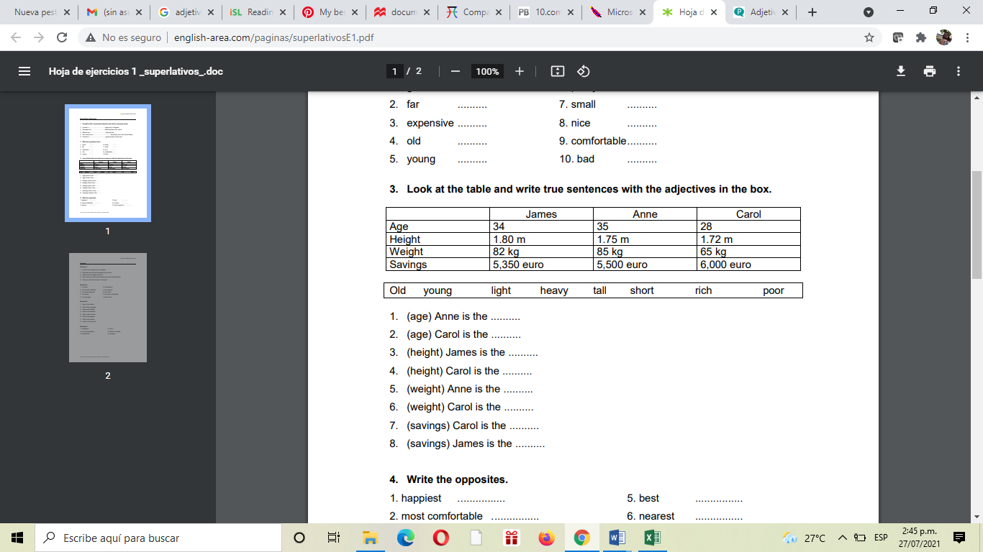

1. (age) Anne is the ..........

2. (age) Carol is the ..........

3. (height) James is the ..........

4. (height) Carol is the ..........

5. (weight) Anne is the ..........

6. (weight) Carol is the ..........

7. (savings) Carol is the ..........

8. (savings) James is the ..........

4. Write the opposites.

1. happiest ................ 5. best ................

2. most comfortable ................ 6. nearest ................

3. easiest ................ 6. most expensive ................

**The Comparative Form of Adjectives**

Complete the following sentences with the correct comparative form of the words listed below.

Bad , important, crowded, good ,high ,heavy, convenient ,difficult,

cheap ,expensive ,quiet ,easy, thin, healthy ,dangerous ,cold

1. In Canada, January is _________________________ than March.

2. I think that good health is ___________________________ than money.

3. I can’t carry my suitcase. It’s much _________________________ than yours.

4. I can afford to buy a new bike but not a new car. A car is ___________________________ than a bike.

5. You look _______________________ than the last time I saw you. Have you lost weight?

6. I couldn’t get a seat in the restaurant. It was ____________________________ than usual.

7. Mountains are __________________________ than hills.

8. He got a very good mark on his exam. The exam was _______________________ than he had expected.

9. You should go to the doctor. Your cold is _____________________________ than it was a few days ago.

10. There is a lot of crime in the big cities. They are _____________________ than the small town where I live.

11. I don’t understand this lesson. It is ______________________________ than the last one we did.

12. I can’t study in this room. It’s too noisy. I’m going to find a _____________________________ place.

13. Our apartment is far from everything. We want to move to a _____________________________ location.

14. Orange juice is __________________________ than Coke.

15. The store is having a great sale today. Most televisions are 25% _____________________ than they were

yesterday.

16. The doctor told me that I can go back to work if I feel ______________________ tomorrow