**a Workshop Adjectives a**

**Name: ________________________________________________**

**1 Unscramble the sentences**

1. milk / our coff ee. / There’s / for / a little

There’s a little milk for our coffee.

1. many / How / she have? / does / bottles
2. onions. / aren’t / any / There
3. is / there? / much / sugar / How

**2.Read and complete the sentences.**

any little few lot many some much

1. I usually eat a little cereal every morning for breakfast.
2. There aren’t_______________ apples in the fridge.
3. How _____________ soda do you drink a day?
4. I like a _____________strawberries for lunch at school.
5. There is ____________orange juice in the fridge.

5. How __________tomatoes are on the table?

**3 Read the words and complete the chart.**

**how much how many**

tomatoes

spaghetti

eggs

juice

oranges

cheese

butter

sugar

strawberries

cereal

apples

onions

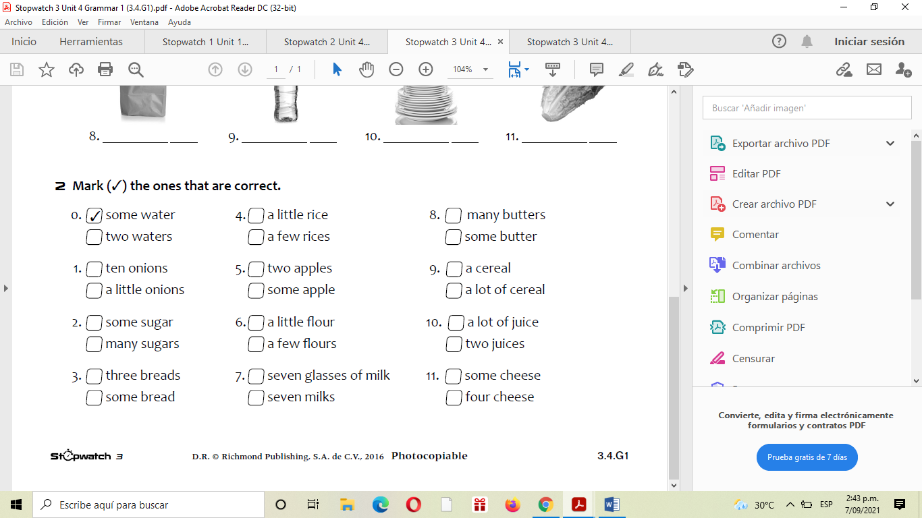

4.

5. **some (+), any (–), any (?)**

**Mark the sentence + (affi rmative), – (negative) or? (a question).**

1. ___There isn’t **any** bread to make a sandwich.

2. ___Are there **any** apples?

3. ___There are **some** strawberries in the fridge.

4. ___There’s **some** orange juice on the table.

5. ___There aren’t **any** potatoes.

**6.Complete the conversation with *some* or *any*.**

**SAM:** Hey, Mom! Do we have ______ milk? I really want ______ cereal.

**MOM:** No, there isn’t ______ milk.

**SAM:** Then I want a sandwich! Is there ______bread?

**MOM:** No. I need to get ______ bread the next time I go to the supermarket.

**SAM:** Well, but there is _______ pizza, isn’t there?

**MOM:** Sorry, Sam. There isn’t ______ pizza either. Have salad!

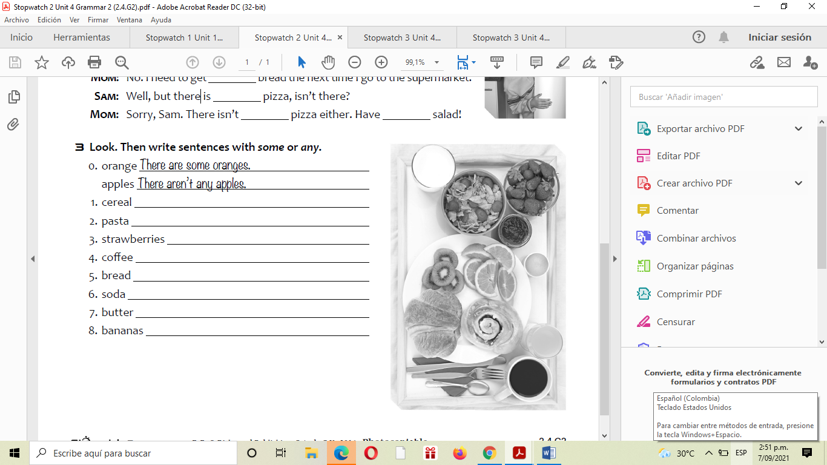

7.

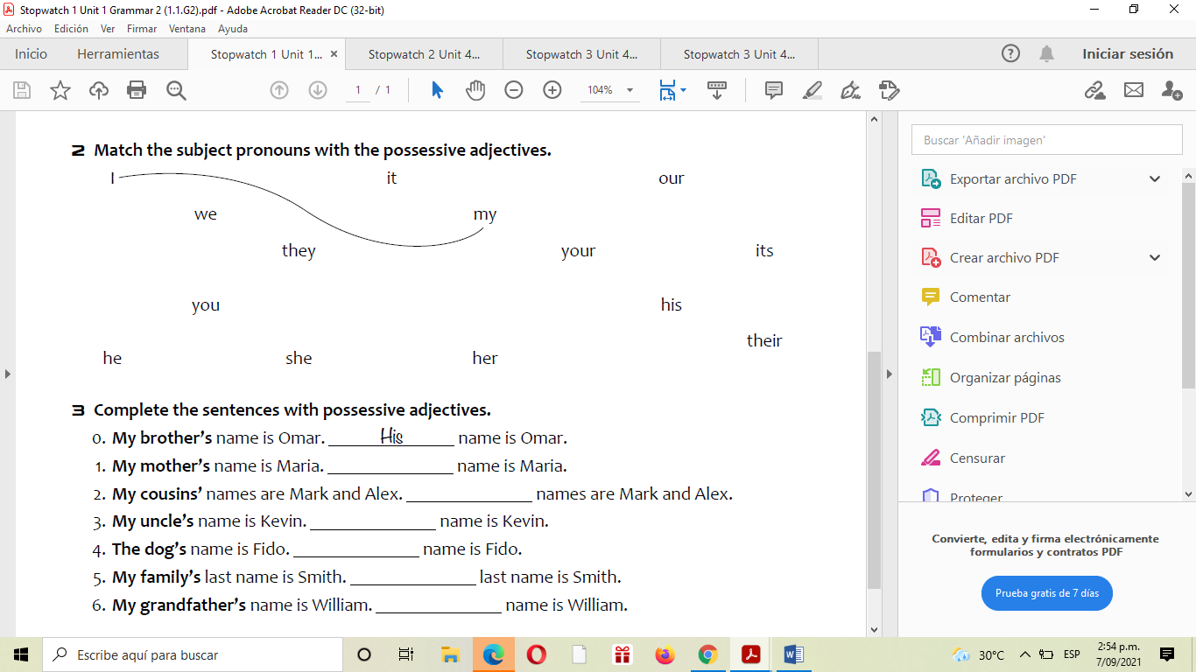

8.

**9. Complete the sentences with possessive adjectives.**

1. **My mother’s** name is Maria. _______name is Maria.

2. **My cousins’** names are Mark and Alex. ________names are Mark and Alex.

3. **My uncle’s** name is Kevin.________ name is Kevin.

4. **The dog’s** name is Fido. ________name is Fido.

5. **My family’s** last name is Smith.________ last name is Smith.

6. **My grandfather’s** name is William. ________name is William.